DSA 0136 OBJECT ORIENTED PROGRAMMING USING C++

14)Write a c++ program for swapping of two numbers using call by value and call by reference

CALL BY REFERENCE

using namespace std;

#include<iostream>

int swap(int \*x,int \*y)

{

int \*temp;

temp=x;

x=y;

y=temp;

cout<<"x is"<< \*x;

cout<<"y is "<<\*y;

return 0;

}

int main()

{

int x,y;

cout<<"enter values of x and y";

cin>>x>>y;

swap(&x,&y);

return 0;

}

Output:

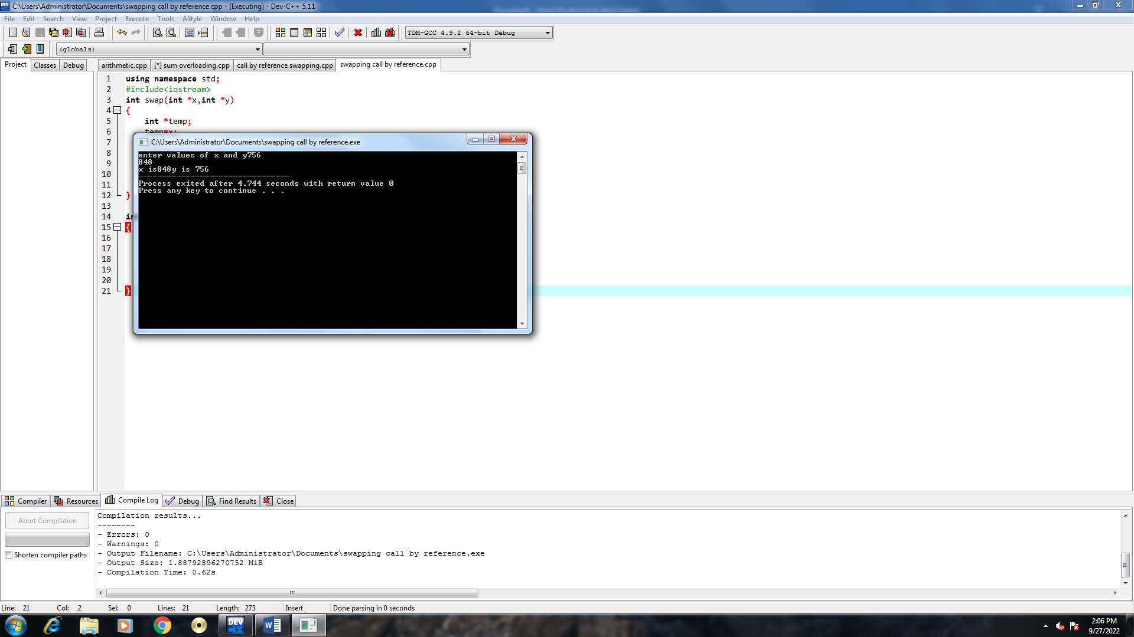

CALL BY VALUE

16)Read a classname rectangle with two datamembers length and breadth and a function call to area to area of rectangle.This class contains three constructors one is having no parameter two have twoparameters three having only oneparameter

using namespace std;

#include<iostream>

class rectangle

{

int l,b,a;

public:

rectangle();

rectangle(int ,int);

rectangle(int);

void calculate();

};

rectangle::rectangle()

{

l=0;

b=0;

}

rectangle::rectangle(int x,int y)

{

l=x;

b=y;

}

rectangle::rectangle(int x)

{

a=x;

}

void rectangle::calculate()

{

cout<<"enter l and b"<<l<<b;

a=l\*b;

cout<<"a"<<a;

}

int main()

{

rectangle r(10,20);

r.calculate();

return 0;

}

Output:

